**Order and Cashier Management System**

Overview

The Order and Cashier Management Project is a System that manage the employee management, order processing, inventory tracking, and sales monitoring. The system features role-based access, where administrators manage employees, stocks, and sales, while cashiers handle orders and payments.

Features

User Authentication : Secure log in functionality for users.

CRUD Operations for users: Create, Read, Update, Delete user information.

View Sales : functionality to view sales.

View Stocks : functionality to view and update stocks

**Screenshots of CRUD Functionality**

Log in

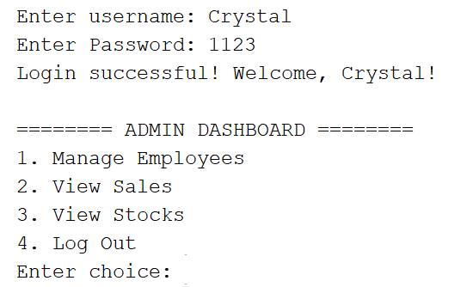

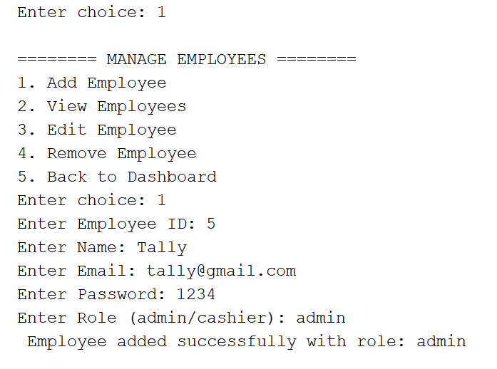Add Employee

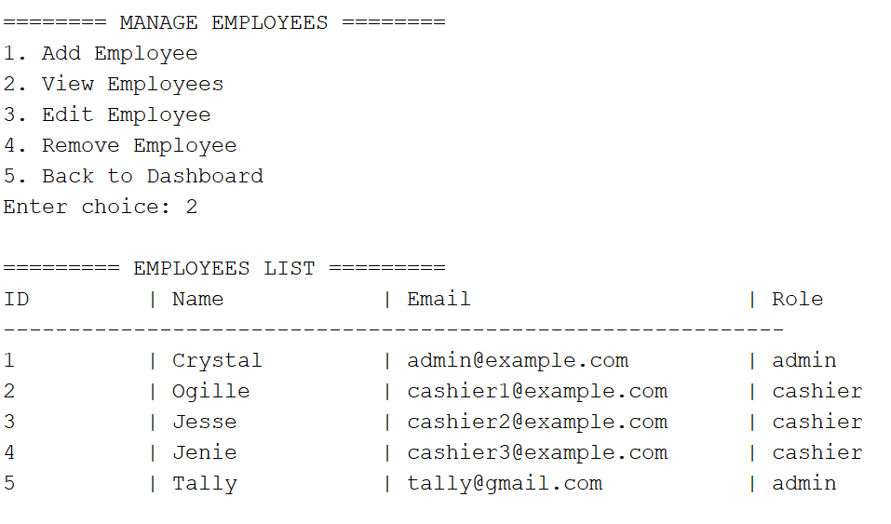View Employees

Edit Employee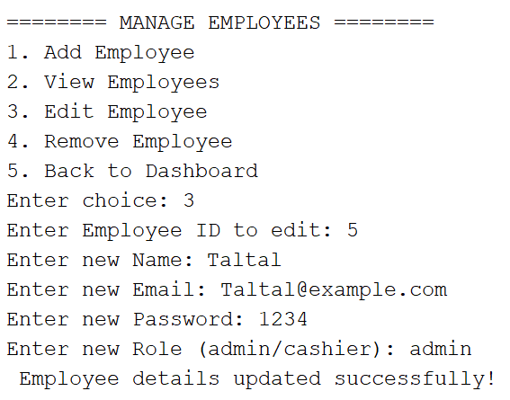

Remove Employee

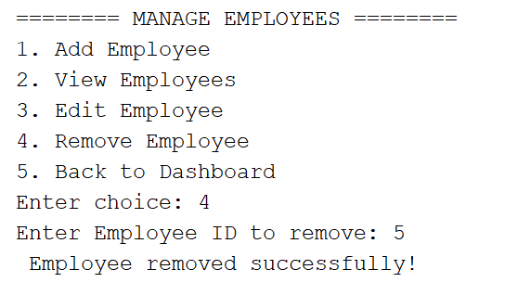

DataBase Schema Diagram

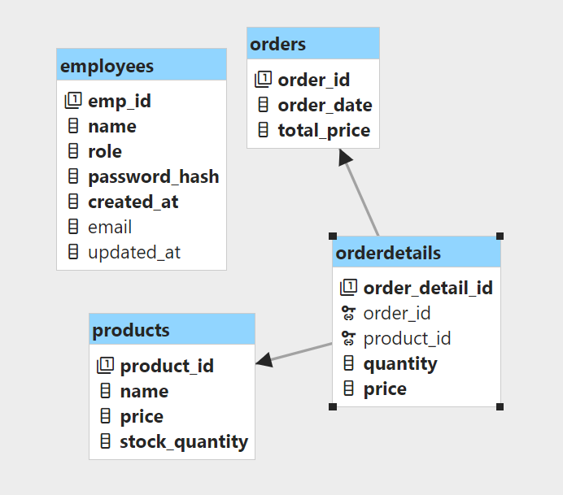

**Code Snippet**

Add Employee

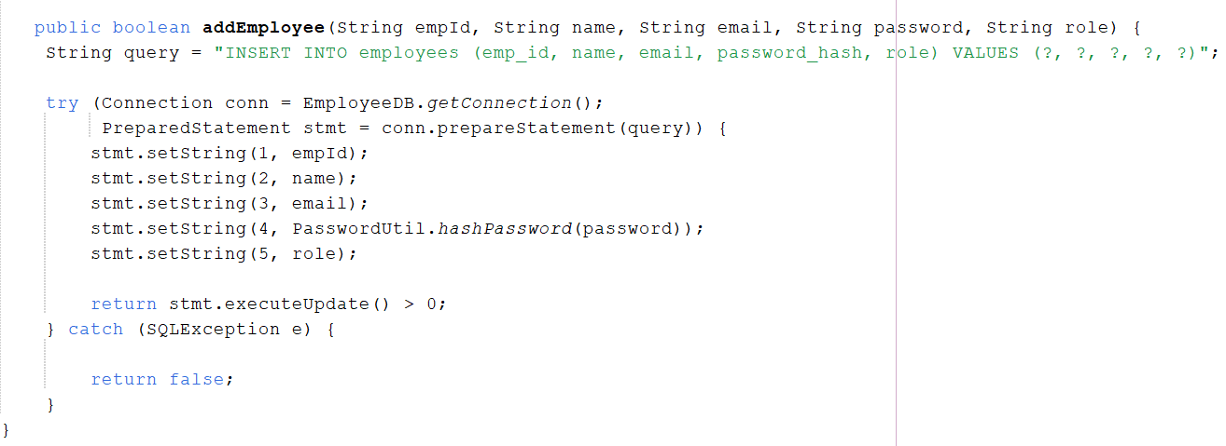

View Employee

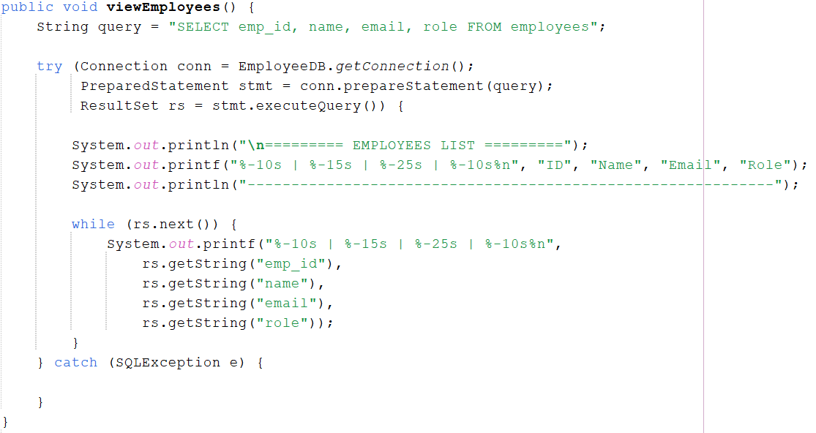

Edit Employee

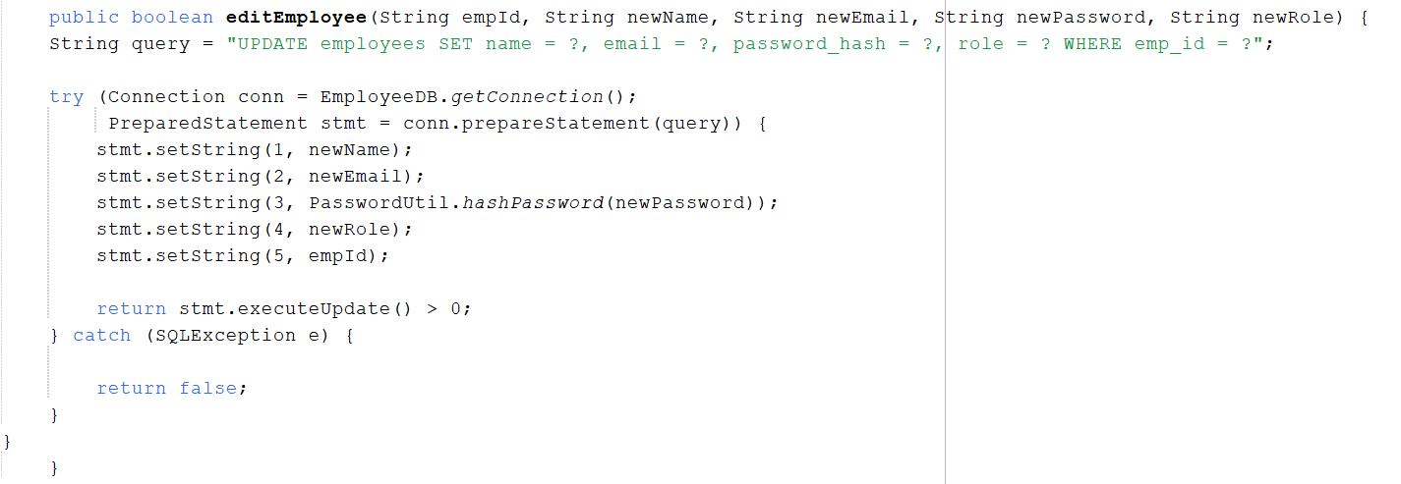

Remove Employee

